BMC Solution Summary for Vicky 13%
In-Bond :
To Book Special PO marked on PO Header & print out PO document in new CN format
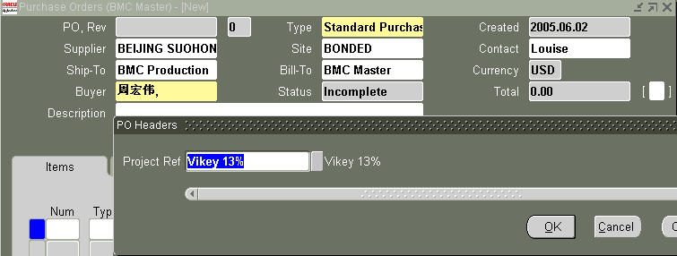

Report name : BMC Purchase Order CN Report

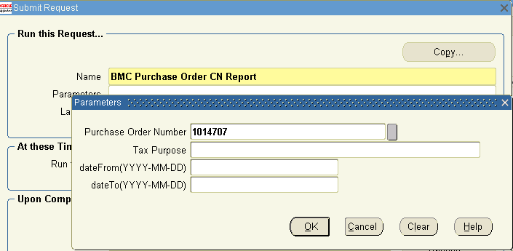

Responsible : Xu Qi (731)
Out-Bond :
To Book this kinds of special SO using SO Type ----PCB 13 Export Order
This will automatic reflect to Below AR Invoice Type & Account number :
AR Invoice Type ----PCB13 Export
5101040101 主营业务收入-主板-出口13 MOR-PCB-Export13
5401040101 主营业务成本-主板-出口13 MOC-PCB-Export13

Responsible : Ren Kai’s Team

Query of out-band data:
